**Requirements Specification System for Target Finder**

By: Devin Taniguchi

Rudy Diaz

Zijun Zhao

# Preface

This document is a project specific requirement document for use by Target Finder system. It provides guidance and specification to clients, project manager from Client Company to understand the system. It is also useful document and provides the project schedule and system design for developers, quality assurances, designers, and project managers from Software Company.

|  |  |  |  |
| --- | --- | --- | --- |
| **Date** | **Version** | **Description** | **Author** |
| 05/04/2016 | 0.1 | Initial preface and Introduction. | Zijun Zhao |
| 05/05/2016 | 0.2 | Added user requirement definition.  Added system architecture. | Rudy Diaz |
| 05/06/2016 | 0.3 | Added system requirement specification.  Added system models.  Added system evolution. | Devin Taniguchi |

# Introduction

The Target Finder system is developed for a Robot Company to make robot moving like human. Machine learning has become one of the most important technological advances during the past two decades, as we try to teach machines how to learn and move like humans. This project simulates the path-finding of the mouse to reach the destination in the shortest steps. Simulation assumes real time environment around the mouse inside the maze. The Target Finder system is an important artificial intelligent simulation for how to create a robot system that is capable of intelligent behavior. It includes functions such as micromouse, maze, direction and AI.

# Glossary

Client: Users who are using Target Finder system in Robot Company.

Administer: A person who manage the whole system.

Quality assurance: A person who is testing and monitoring for the system working properly.

A.I.: Artificial Intelligence; A simulated approach taken by a computer to replicate human learning.

User-controlled operations: The operations/actions taken by the user to control their mouse within the system

Module: A subsystem; the inner working of a system within another system.

# User requirements definition

Target Finder allows for user-controlled operations of the mouse to navigate through a given maze. This will allow the user to use their mouse throughout the maze and the computer will save each pathway the user takes. Once the maze is completed, Target Finder will calculate which pathways requires the least amount of steps to complete the maze. This calculation will generate the shortest pathway in order for any robot to navigate in the most efficient way possible.

* 1. **Non-Functional Requirements**

**4.1.1 Response Time**

The act of saving the taken pathways of the mouse through a given maze allows a better understanding of what trajectories gives the most time-efficient movement for a robot. Generating a better response time through a maze for a robot will enable robots to move quickly by simulating the learning aspect of humans.

**4.1.2 Utilization and Usability**

Users will be able to implement a learning aspect into robots. This learning capability will allow robot to be time-efficient when movement is a factor. The usability of implementing Target Finder will enable different robots with the capability of time-efficient movement via simulated human learning.

**4.1.3 Data Integrity**

The usage of Target Finder and trajectory saving will be stored within the users robot. This will allow the user to access that information and see how each trajectory affects the time management of the robot.

# System architecture

The following two diagrams represent the inner module workings within Target Finder. Furthermore, a use case diagram will explain the functionalities that the client and administer will have within the system.

* 1. **System Diagrams**

The following diagram will show and explain the inner working of the modules within Target Finder. It will also explain the relationship of the system with the user

* + 1. **Module Relationship**

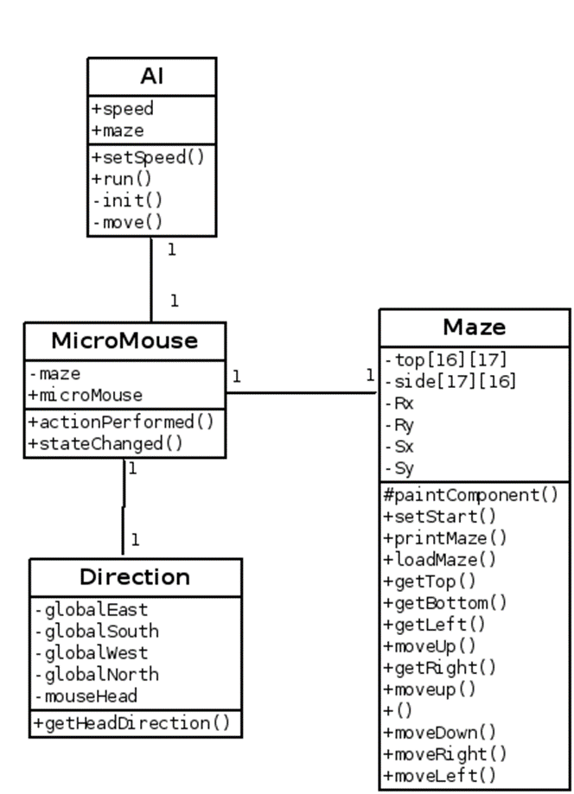

The Class Diagram above the relationship between each module. Each module has a one-to-one relationship that interacts with each other via the central MicroMouse module. The Direction module enables the overall direction that the mouse is taking within the maze. The Maze module generates a maze for the user’s mouse to take. The A.I. module analyzes the speed of the mouse and the movements taken by the mouse.

* + 1. **Client – Administer Use Case Diagram**

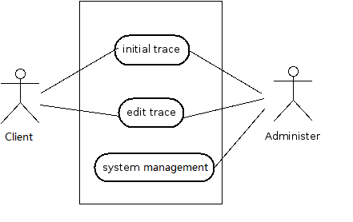

The user/client will be able to maneuver the maze with their mouse. Furthermore, the client will also be allowed to edit the conditions of which maze to use, the speed of the mouse, and its direction. The administrator will manage both the initial trace and edit trace functionalities alongside the system management to ensure the Target Finder is working properly.

# System requirements specification

# System models

# System evolution

# Index

A.I., 5

Client, 3

Administer, 3

Quality assurance, 2

Machine learning, 2

Module, 5

User-Controlled Operations, 4